PRCTICAL -5B-BATCH T3

PRN -2018BTECS00009

TO DESIGN AND DEVELOP WEB PAGES USING HTML FUNDAMENTAL AND FORMATTING ELEMENTS

Problem Statement 1:

Design and develop a static web page using HTML for Sports blog. Access it locally and in LAN using web server. It should have following sections:

1. Header – Title and authorship information of a blog

2. Three links to other sports blogs

3. Article – At least two articles should be there

4. Contact Information of author It should have following tag

1. Use semantic tags appropriately (, , , , and)

2. Use <h1> to <h6> tags at least once.

3. Use single line break tag.

4. Use <a> tags in the articles with the absolute and relative URLs.

5. Use thematic grouping for different sections and articles using <hr> tag.

6. Use <strong> and <em> instead of <b> and <i> resp.

7. Use <address> tag for displaying author’s information.

Answer-

Code

<!DOCTYPE html>

<html lang="en">

<head>

 <meta charset="UTF-8">

 <meta http-equiv="X-UA-Compatible" content="IE=edge">

 <meta name="viewport" content="width=device-width, initial-scale=1.0">

 <title>Sports</title>

 </head>

 <body>

 <header>

 <H1>TECHNOPEDIA</H1>

 <ul>

 <li>HOME</li>

 <li>ABOUT</li>

 <li>CONTACT</li>

  </ul>

  </header>

  <main>

  <article>

  <section>

  <h2>What is sports?</h2>

  <p>

  Sport is commonly defined as an athletic activity that involves a degree of competition, such as netball or basketball. Some games and many kinds of racing are called sports. A professional at a sport is called an athlete. ... Sports can be played indoors or outdoors and by individuals or team.

  </p>

</article>

</section>

<section>

<h3>sports</h3>

<img src="sports.jpg" alt="img">

</section>

<section>

<h3>What Does a sport  Do?</h3>

                        Sports also plays a crucial role in uplifting a nation's economy. The world of sports plays a significant role in building a healthier society by bringing people from all walks of life together. Sports play a crucial in influencing people's lives as it helps in promoting a culture of fitness.

</section>

<section>

 <h3>Why Become a sportsman?</h3>

  <p>

    physical fitness and conditioning. improved balance, coordination and body control. increase in sport skills and competitive skills. increase in self-confidence and social skills.

</p>

 <div>

  <h3>Whats sports make you fit?</h3>

  <p>

    Running. If you want to get fitter without spending too much money, running is the perfect sport. And, according to Runner's World, a 160lb person will burn around 720 calories on a one-hour/6-mile run. It's obvious then why running is one of the best sports to keep fit.

</p>

<strong>Skills needed:</strong>

The fundamental movement skills to be developed through Health and Physical Education include:locomotor and non-locomotor skills — rolling, balancing, sliding, jogging, running, leaping, jumping, hopping, dodging, galloping and skipping. object control skills — bouncing, throwing, catching, kicking, striking

</div>

</section>

</article>

<section>

<br>

<div>

Are you searching for sport careeer opportunities?

<a href="https://leverageedu.com/blog/career-in-sports/">click here</a>

</div>

 <div>

 <b>Related-</b>

 </div>

 <a href="https://www.ldoceonline.com/dictionary/sports-centre">What is a sport centre?</a>

  <br>

  <br>

</section>

<div>

<pre>

<strong>About author</strong>

Dr. R. D. Sharma is Assistant Professor in Department of Computer Science and Engineering at IIT Bombay, Maharashtra. He has received his Bachelor of Engineering (BE), Master of Engineering (ME) in Computer Science and Engineering from Walchand College of Engineering, Sangli and Ph.D. from Indian Institute of Technology Roorkee.

</pre>

</div>

</main>

<footer>

 <p>

 &copy; Copyrights Technopedia. All rights are reserved.

</p>

</footer>

</body>

</html>

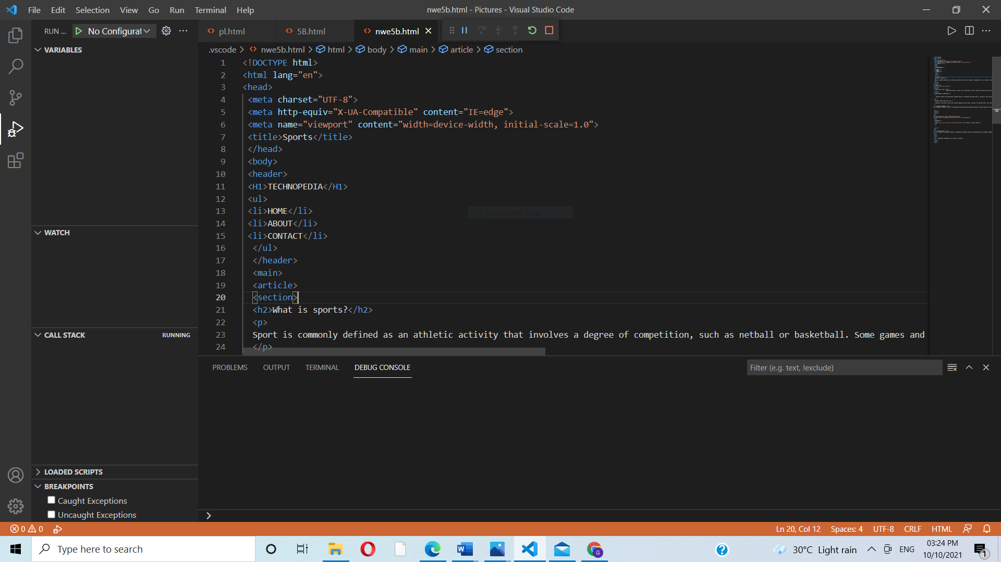

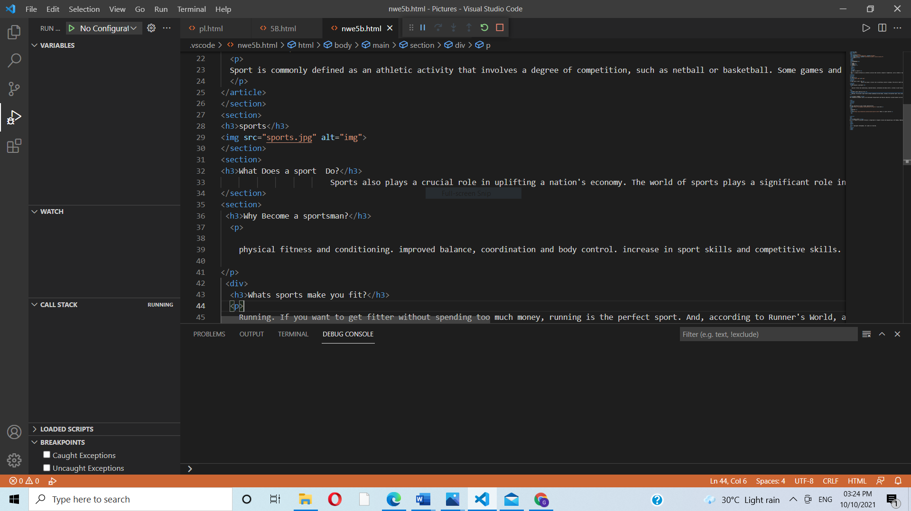

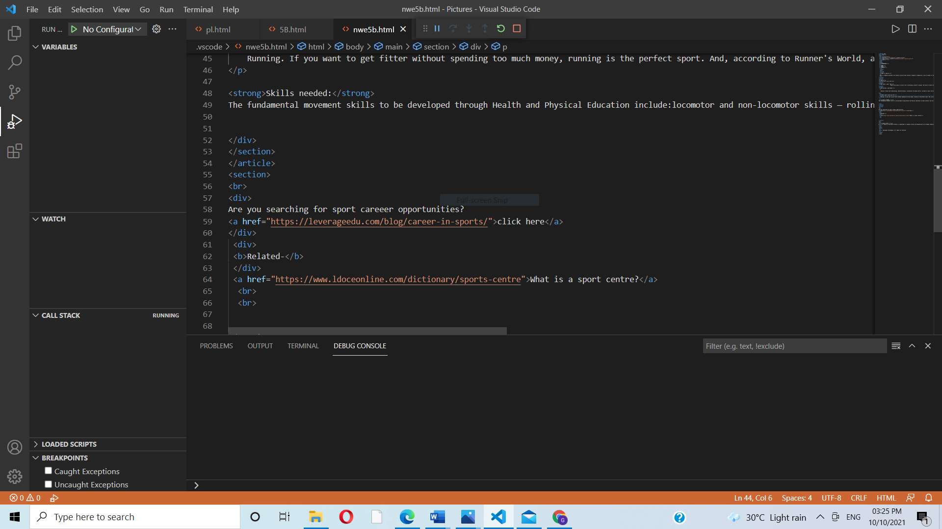

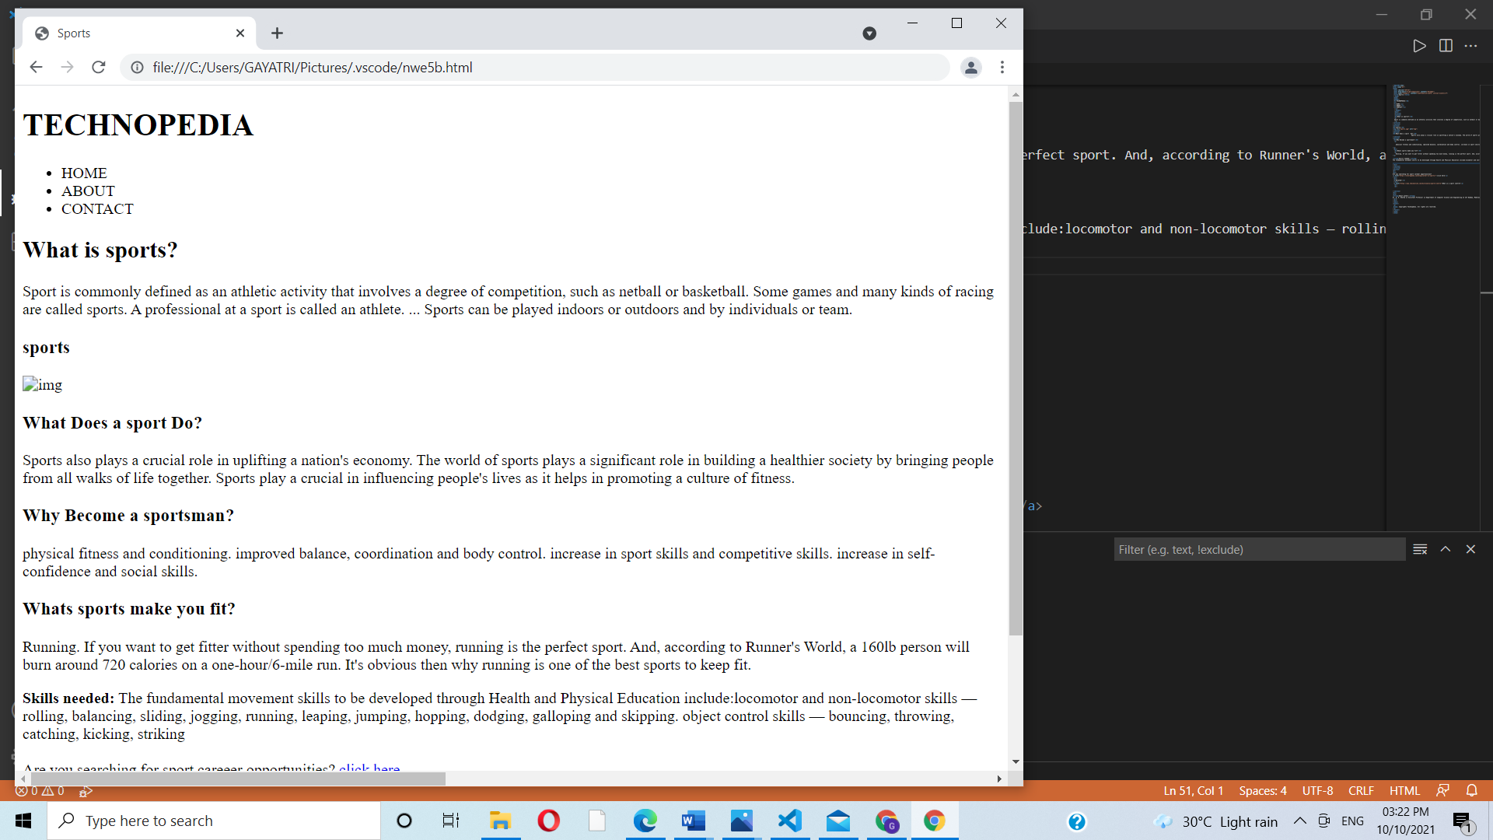

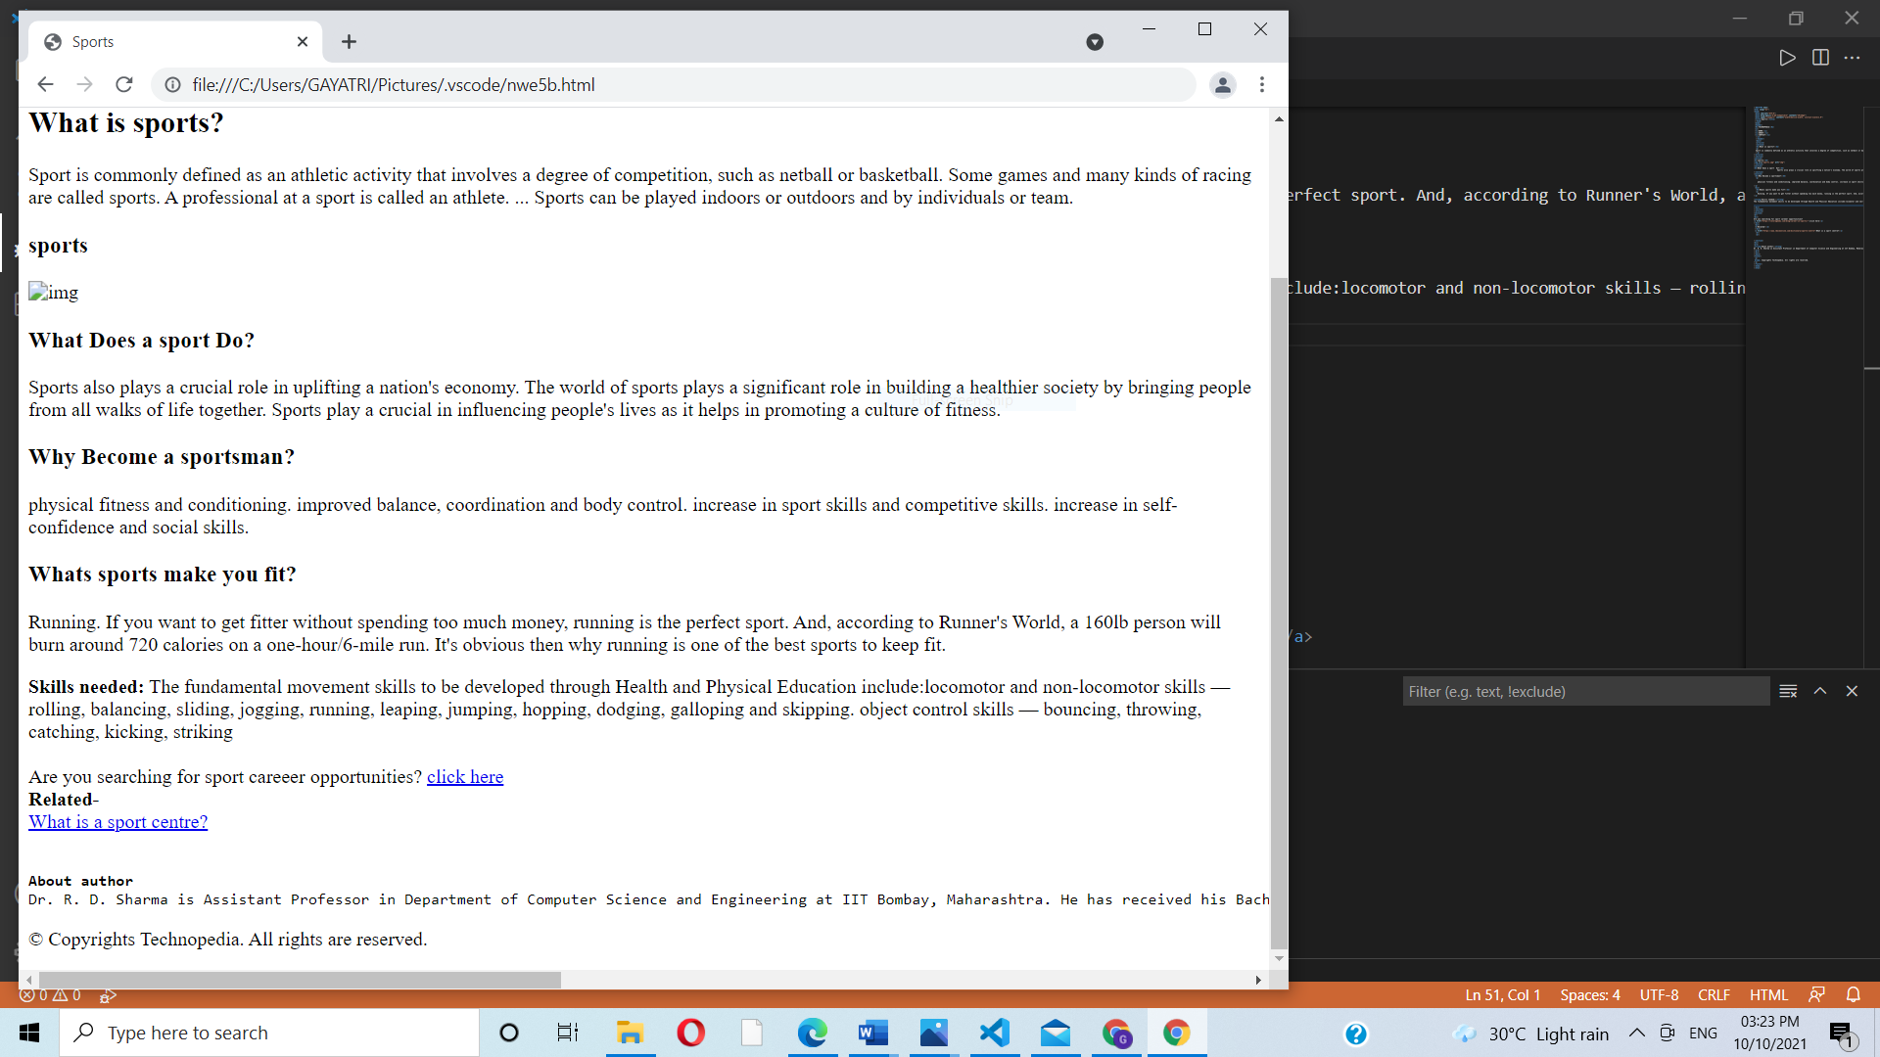

Problem Statement 2:

Design and develop a static web page using HTML for following requirement. Access it locally and in LAN using web server. It should have following sections:

1. Problem Statement: Write a program in any language to find the sum of the series 1 +11 + 111 + 1111 + ... n terms.

2. Code

3. Sample Input

4. Sample Output

5. Variables used in the program

6. Complexit

It should have following tags:

1. Use semantic tags appropriately (, , , , and )

2. Use , , , and *at least once.*

*3.* *Use <s>, <small>, <sub> and <sup> at least once*

*4. Use <h1> to <h6> tags at least once*

*5. Use single line break tag.*

*6. Use thematic grouping for different sections using <hr> tag.*

*7. Add the reference link for the algorithm using <a> tag.*

*Answer-*

*Code-*

#include<iostream>

using namespace std;

int main()

{

int n;

int sum=0,i;

cout<<"Enter the range of number:";

cin>>n;

int p=1;

for(i=1;i<=n;i++)

{

sum+=p;

p=(p\*10)+1;

}

cout<<"The sum of the series = "<<sum;

}

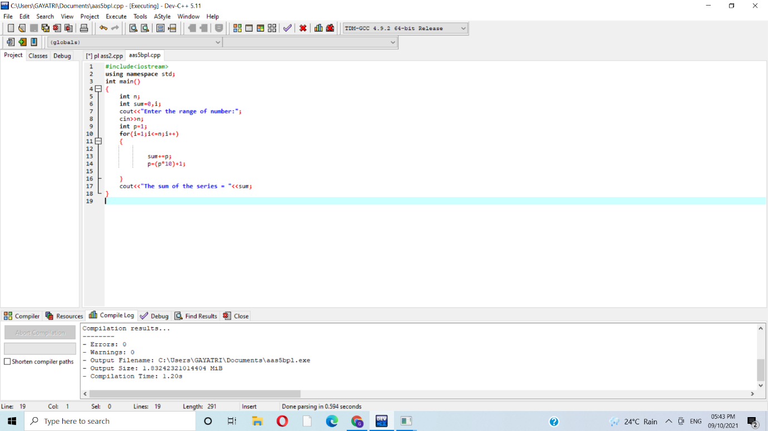

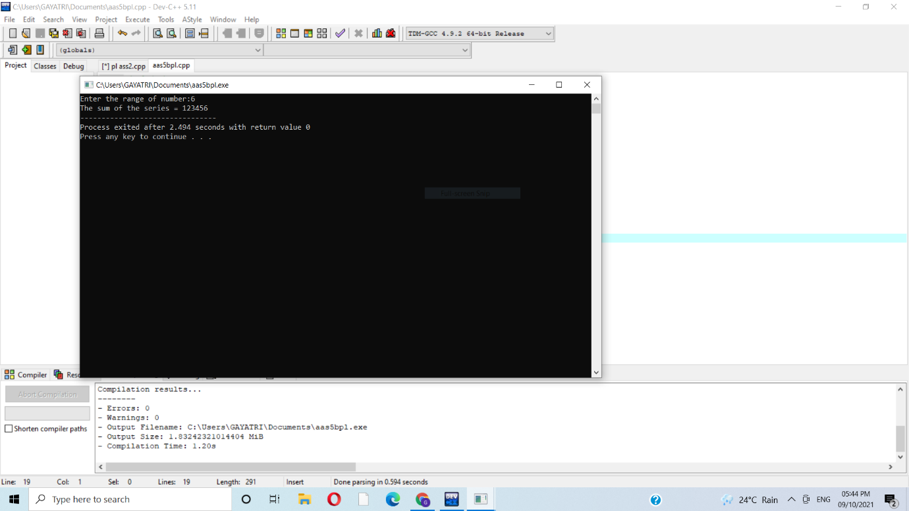

*3.sample input=6*

*4.sample output=123456*

*5.variables used=int sum,sum+*

*Problem statement 3-*

*Design and develop a static web page using HTML for following requirement. Access it*

*locally and in LAN using web server.*

*It should have following sections:*

*1. Any three quotes from https://www.brainyquote.com/ with the name of person*

*who quoted it.*

*It should have following tags:*

*1. Use semantic tags appropriately (<section>, <header>, <footer>, <article>,*

*<aside> and <nav>)*

*2. Use <blockquote> and <quote> tags.*

*3. Use <h1> to <h6> tags at least once.*

*4. Use single line break tag.*

*5. Use thematic grouping for different sections using <hr> tag.*

*6. Add the reference link using <a> tag*

*Answer-*

*CODE-*

<<!DOCTYPE html>

<html lang="en">

<head>

<title>Brainy Quote</title>

</head>

 <body>

 <header>

 <h1>

<q>Motivational Quotes</q>

</h1>

</header>

<article>

<section>

<blockquote>

Infuse your life with action. Don't wait for it to happen. Make it happen. Make your own future. Make your own hope. Make your own love. And whatever your beliefs, honor your creator, not by passively waiting for grace to come down from upon high, but by doing what you can to make grace happen... yourself, right now, right down here on Earth.

<em>-Bradley Whitford</em>

</blockquote>

</section>

<section>

<blockquote>

Consult not your fears but your hopes and your dreams. Think not about your frustrations, but about your unfulfilled potential. Concern yourself not with what you tried and failed in, but with what it is still possible for you to do.

<em>-Pope John XXIII</em>

</blockquote>

</section>

<section>

<blockquote>

I learned that we can do anything, but we can't do everything... at least not at the same time. So think of your priorities not in terms of what activities you do, but when you do them. Timing is everything.

<em>-Dan Millman</em>

</blockquote>

</section>

</article>

<footer>

<h2>

<a href="https://www.brainyquote.com/">Visit Us</a>

</h2>

</footer>

</body>

</html>

